Mrs. Nicolo
Technology Class
www.homestead.mrsnicolo.com

You need 4 pictures of your assigned country
and 4 pictures of attractions in your country (places of interest to visit)
TOTAL 8 PICTURES

- Citing your sources from the Internet is a MUST

- Use NoodleTools to cite the websites where the pictures were found

- Go to http://noodletools.com/

- NoodleTools will help you. You have an account.

- Use the same USERNAME and PASSWORD you use in school.

This is your first screen.
Click on the GREEN rectangle (NoodleBib MLA Starter). Arrow shows where it is.

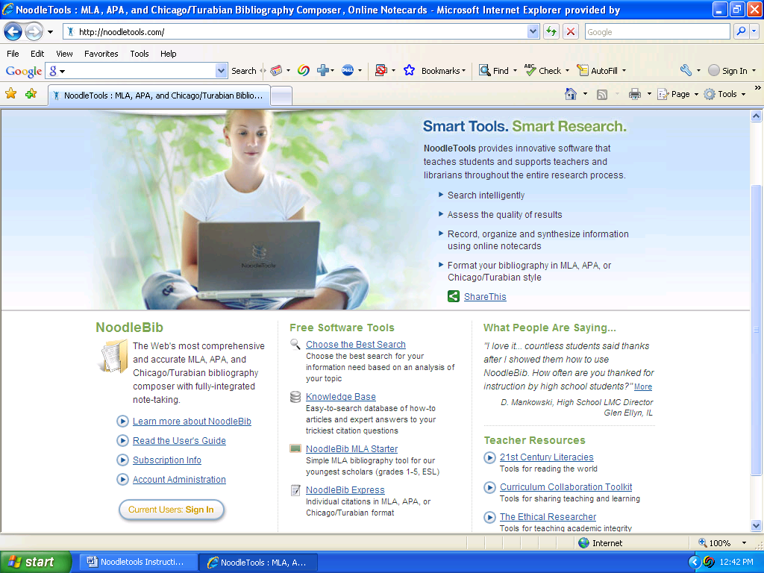

Type in your Personal ID (same Username as you use in school)
Type in your Password (same Password as you use in school)

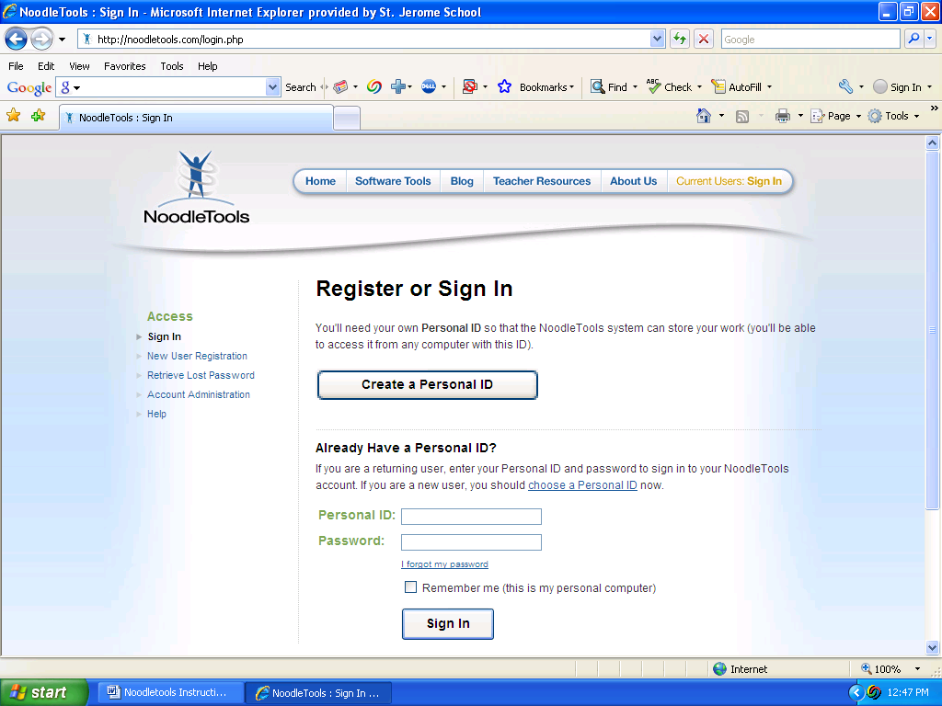

Open the folder you created in school with YOUR assigned country(You will only have 1 folder)

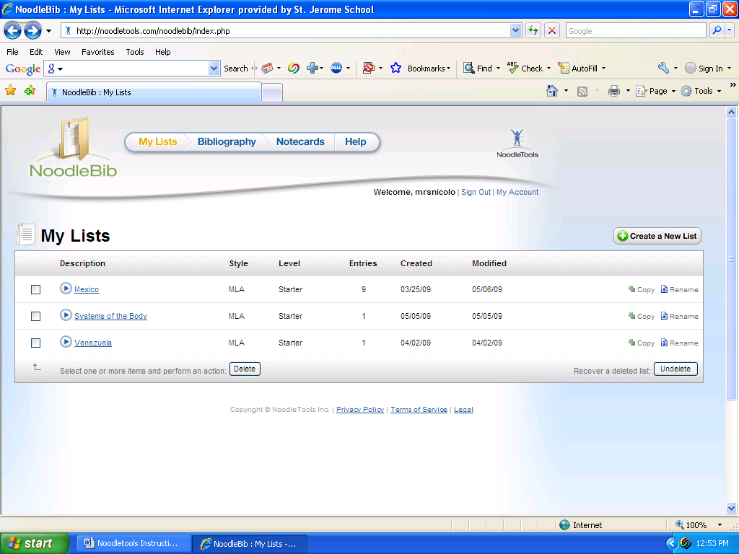

At the top click on Cite a: Choose Website - then - click Create Citation
Begin to cite your sources.

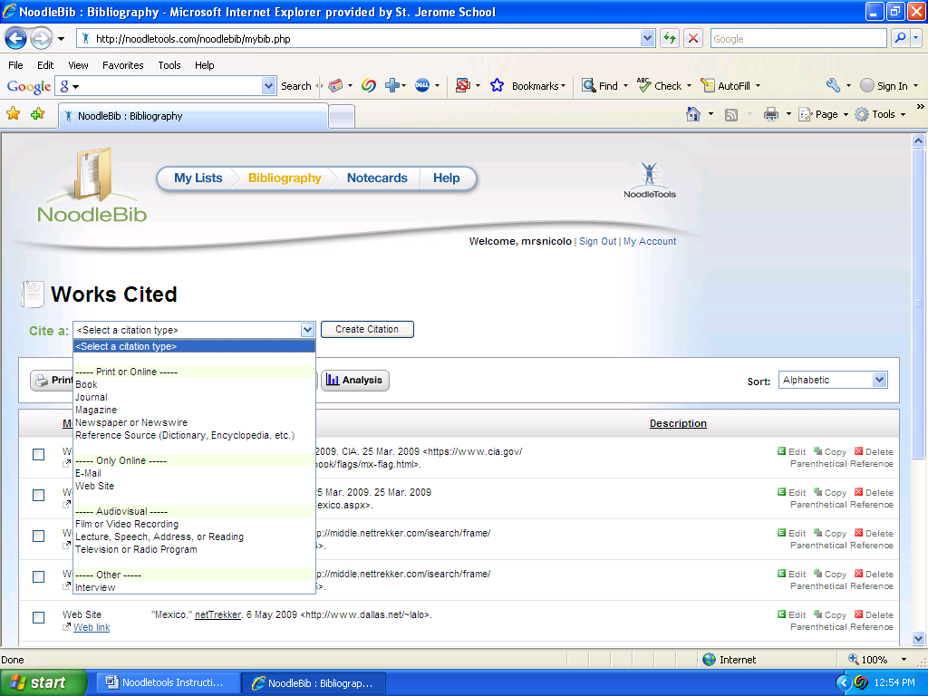

General Website should be selected (if that is what you are using) and click – NEXT

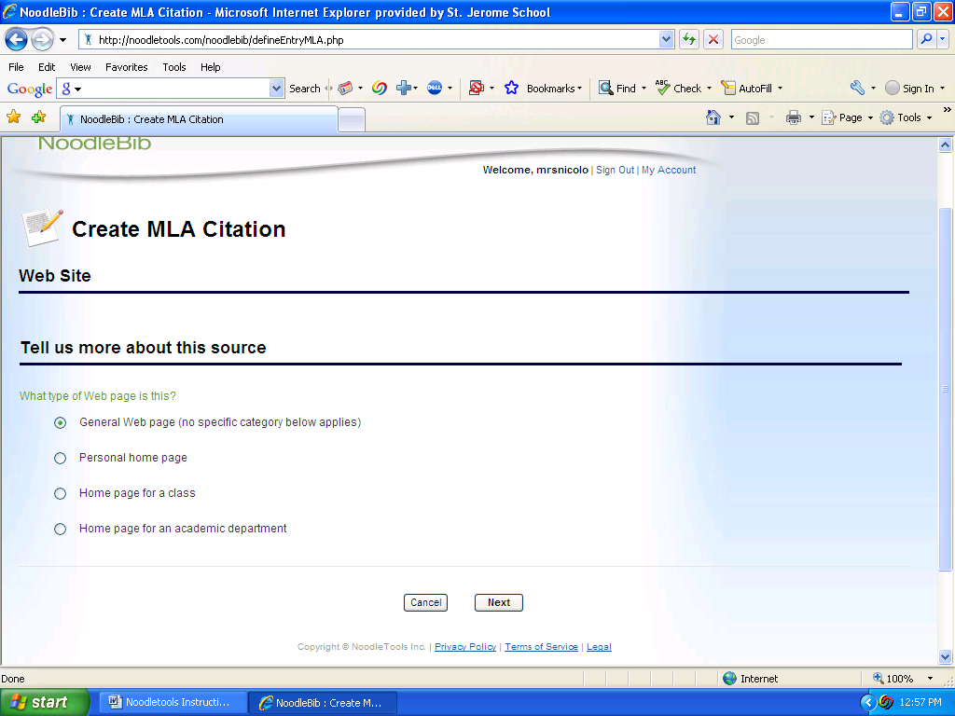

Begin to type in the information it asks you for. Required boxes MUST be filled in.

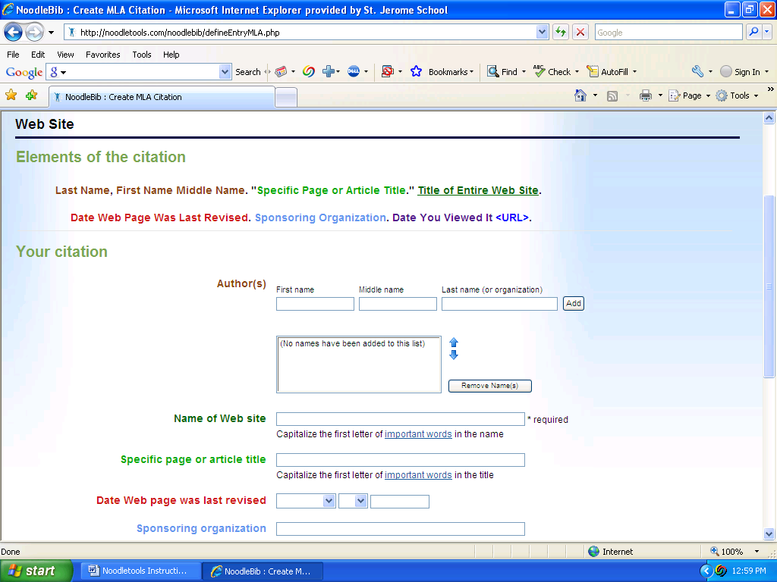

You MUST fill in all circled required information boxes. You can fill in the rest if you know it.
When finished typing in the information you need – Click on GENERATE THE CITATION.

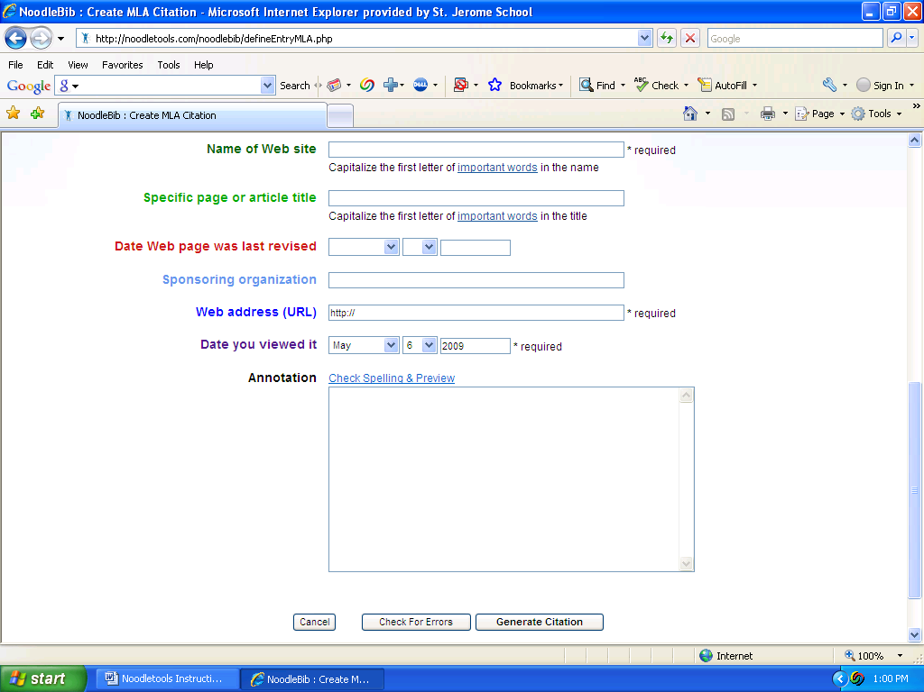
Type in your country
NoodleTools will then list each of your citations in your country’s folder and put a link to the website where your picture is. You will then use this in school to finish your Powerpoint.

